Practice Assignment 3 – Stepwise Refinement

- Create a Pinsetter Robot that will work at a bowling alley to set up the pins in the pattern below:
  - Use pseudocode to develop two different refinements for a method named setPins
  - Analyze both for strengths and weaknesses
  - 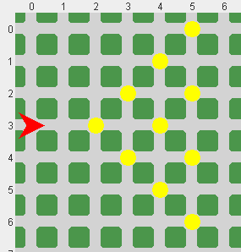Write a program to implement one of the refinements.

A.

Model 1:

Static main
Move Robot to pin position
Call the place method
End of Static Main

